# Coffin Bay KBA, South Australia

BirdLife Australia Key Biodiversity Area (KBA) Change Detection Report

Prepared for [BirdLife Australia](https://birdlife.org.au/) by [Michael Dear](https://mjdear68.github.io/portfolio/), April 2024

## Links

[Coffin Bay BirdLife Factsheet](http://datazone.birdlife.org/site/factsheet/coffin-bay-iba-australia)

## Glossary

Mean: the average of a set of numbers.

Normalised Difference Vegetation Index (NDVI): The NDVI is a common remote sensing index used for the assessment of vegetation cover and vigour. The NDVI has values in the range of -1 to 1. Values below 0 are generally associated with deep water. Values above 0.8 are associated with dense forest.

Masked: Pixels that were excluded from the dataset due to a lack of data e.g. cloud cover

## Key Points

* A much larger area of the KBA was classified as medium density vegetation in 2023 than in 2024 or for the mean of 2019 to 2023. This could be due to higher rainfall or error introduced by atmospheric or other noise effects.
* Other land cover classes were found to be relatively stable.

## Method

Sentinel 2 satellite data was obtained from [Digital Earth Australia's](https://www.dea.ga.gov.au/) Open Data Cube for the period January to March in each year from 2019 to 2024. Each hectare in the study area was represented by one pixel in the dataset. NDVI and 5-year mean datasets were produced. True-colour (RGB) and NDVI images of the KBA and its surrounds were plotted and reviewed. A classification was developed using NDVI thresholds, from which class change matrices were produced.

## Plots

### True-colour (RGB) Plots

These plots show a true-colour representation of the KBA and its surrounds. The KBA boundary is shown in orange.

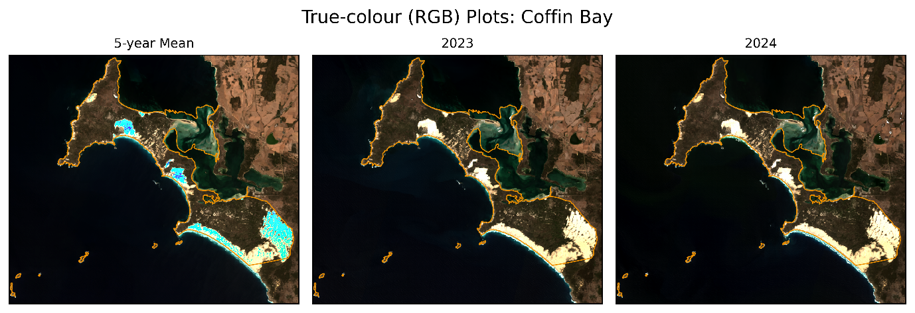

The blue areas within the KBA boundary in the 5-year mean are possibly an artefact caused by the aggregation process. There is a large agricultural area to the north-east of the KBA which could be a source of nutrient and pesticide runoff.

### Normalised Difference Vegetation Index (NDVI)

The NDVI plots indicate the regions of higher and lower 'greenness' for each period. The medium density vegetation areas appear to be greener in 2023 than in 2024. This situation is highlighted in the NDVI Classification plots by the larger extent of the Medium Density class in 2023. No vegetation in the KBA was classified as High Density during the study period.

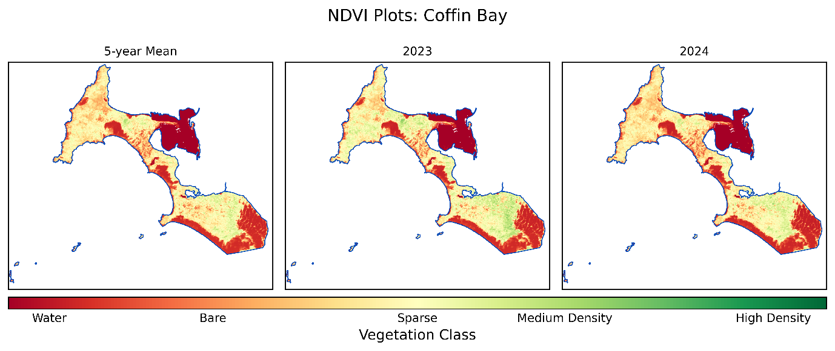

## Class Change

The following table displays the area for each class in the current year as a percentage of the total area for each class from the previous year. The rows of the table represent 2023 and the columns represent 2024. Almost half of the vegetation classified as Medium Density in 2023 was classified as Sparse in 2024. The RGB plots of the KBA do not suggest that this change is due to vegetation clearing. The remaining classes show little change.

|  |  |  |  |  |  |  |  |
| --- | --- | --- | --- | --- | --- | --- | --- |
|  |  | 2024 | | | | | |
| 2023 |  | **Water** | **Bare** | **Sparse** | **Medium Density** | **High Density** | **Masked** |
| **Water** | 97.0 | 2.9 | 0.0 | 0.0 | 0.0 | 0.1 |
| **Bare** | 1.4 | 98.3 | 0.3 | 0.0 | 0.0 | 0.0 |
| **Sparse** | 0.0 | 2.5 | 96.9 | 0.5 | 0.0 | 0.0 |
| **Medium Density** | 0.0 | 0.0 | 46.5 | 53.4 | 0.0 | 0.0 |
| **High Density** | NaN | NaN | NaN | NaN | NaN | NaN |
| **Masked** | 18.2 | 9.1 | 36.4 | 4.5 | 0.0 | 31.8 |